

Al Imam Muhammad ibn Saud Islamic University College of Computer and Information System

Computer Science Department

1st semester 1444 H – 2022 G

**CS 438 – Internet Technologies**

**Project**

**[Car Rental Website ]**

**By**

| Student Name | ID |
| --- | --- |
| Abdulmalik alkhalifha | 440023938 |
| nasser alowkan | 439015269 |
| abdulelah al-enzi | 439015929 |

[16/8/2022]

In this project, We created and established a car rental system website to make it easier to enter the data needed for the people who work in the company. God willing, our objective is for it to be seamless and simple to use for all categories supplied.

## 1. Site Map

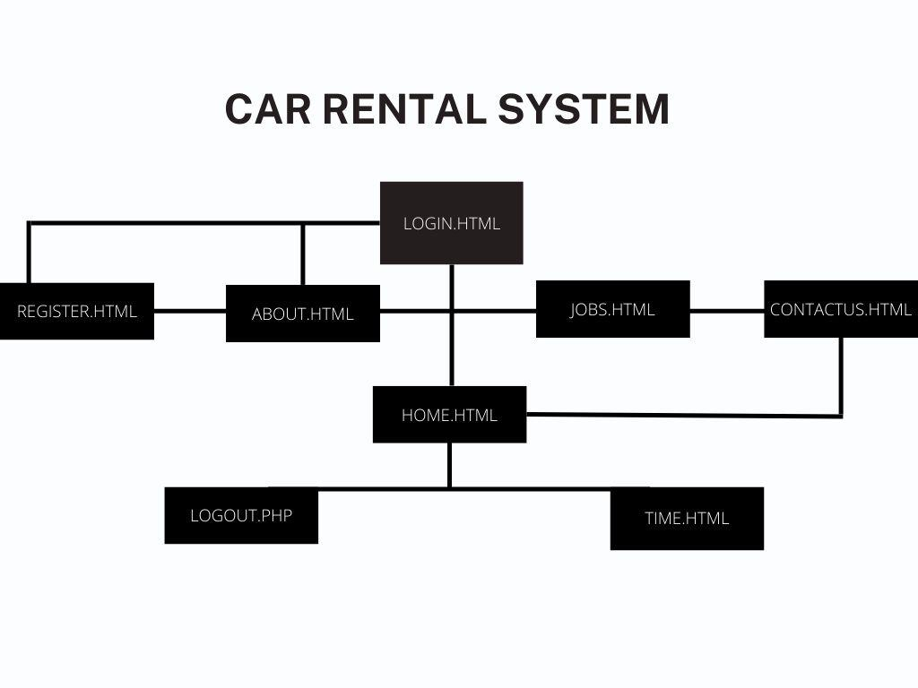

## 2. Look & Feel

We employed a variety of stylistic techniques for the project, including background-image, repetition, size, font, decoration, color, text-align, and more, more.]

[<https://www.geeksforgeeks.org/> , <https://www.w3schools.com/> , www.stackoverfolw.com ]

## 3. Dynamic Components

[time.js] [time.php]

## 4. Business Logic

[We established a database named my site and two tables. The first table has six variables: the driver's name, the name of the vehicle company, the name of the automobile, the car model, the date the car was taken, and the date the car was returned. The second table is about users and contains three user names, as well as email and password information.

[Table info has 6 attributes: 1-driverName → VARCHAR(45) NOT NULL

2-carCompany → VARCHAR(45) NOT NULL

3-carName → VARCHAR(45) NOT NULL

4-carModel → VARCHAR(45) NOT NULL

5-pickDate → Date Default NULL

6-returnDate → Date Default NULL

Table users has 3 attributes: 1-username → VARCHAR(150)

2-email → VARCHAR(100)

3-password → VARCHAR(10)

]

# References

[<https://www.w3schools.com/> , <https://www.geeksforgeeks.org/> , <https://stackoverflow.com/>, https://html.com]